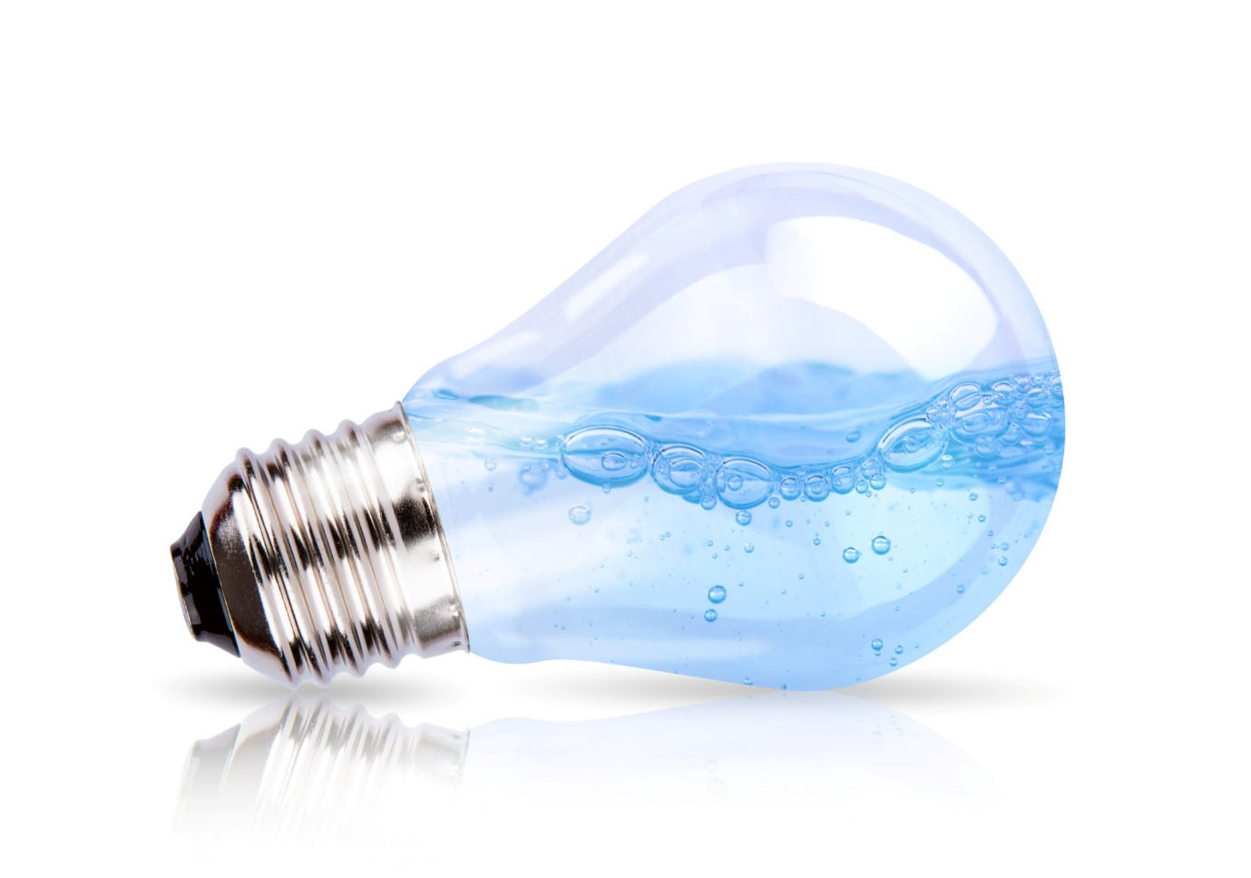

How to Get DEWA Approvals in Dubai: Step-by-Step Process & Checklist
Obtaining building approvals in Dubai involves multiple authorities, and DEWA approval is one of the most critical stages. Whether you are constructing a new building, renovating an existing property, or carrying out a commercial fit-out, DEWA approval is mandatory to legally connect electricity and water services.
This guide explains how DEWA fits into Dubai’s building approvals system, the step-by-step DEWA approval process, and a complete list of documents required to avoid delays.
What Is DEWA and Its Role in Building Approvals?
The Dubai Electricity and Water Authority (DEWA) is the official government body responsible for approving and supplying electricity and water in Dubai. As part of the overall building approval process, DEWA ensures that all electrical and plumbing systems comply with Dubai’s safety, sustainability, and load regulations.
No project can receive final building approvals or completion certification without DEWA clearance.
Why DEWA Approval Is Mandatory for Building Approvals
DEWA approval plays a key role in building approvals because it ensures:
- Safe electrical and water system design
- Accurate load capacity planning
- Compliance with Dubai Municipality regulations
- Fire and electrical hazard prevention
- Long-term utility reliability
Without DEWA approval, your building approval application may be rejected or delayed indefinitely.
Types of DEWA Building Approvals in Dubai
Depending on the project scope, DEWA building approvals may include:
- Electrical design approval
- Water design approval
- Electrical load approval
- Temporary construction power approval
- Permanent electricity and water connection approval
- Meter installation approval
Each stage must be cleared before moving to the next phase of building approvals.

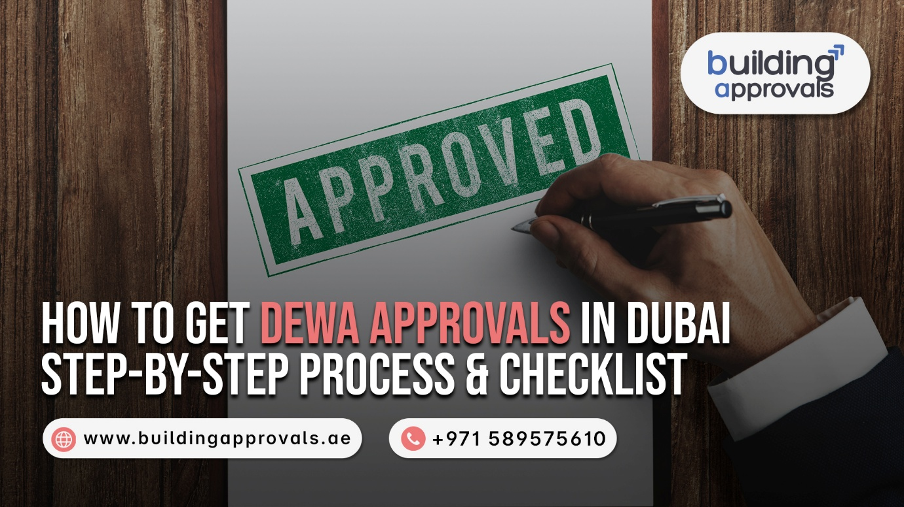
Step-by-Step DEWA Approval Process for Building Approvals
1. Appoint a DEWA-Approved Consultant
All DEWA applications must be submitted by a DEWA-approved consultant or contractor. This is a mandatory requirement for building approvals in Dubai.
2. Prepare DEWA-Compliant Drawings
The consultant prepares electrical and water drawings aligned with:
- Dubai Municipality approvals
- Approved architectural and MEP layouts
- DEWA technical standards
Accuracy at this stage helps speed up the building approval process.
3. Online Submission for Building Approvals
DEWA approvals are submitted through DEWA’s online portal, ensuring transparency and faster processing for building approvals.
4. Technical Review by DEWA
DEWA engineers review the submission and may:
- Approve the design
- Issue technical comments
- Request revisions or additional documents
Prompt responses help avoid delays in building approvals.
5. DEWA Design Approval Issuance
Once all comments are resolved, DEWA issues official approval, allowing electrical and water works to begin.
6. Site Inspection & Final Building Approval
After installation:
- DEWA inspects the site
- Verifies compliance with approved drawings
- Approves meter installation and utility connection
This stage is essential for final building approvals and occupancy permits.
Documents Required for DEWA Building Approvals
General Building Approval Documents
- DEWA application form
- Trade license (commercial projects)
- Owner’s Emirates ID or passport copy
- Consultant and contractor licenses
Property & Authority Documents
- Title deed or Ejari
- Location map and plot details
- Dubai Municipality building approval
- Approved architectural and MEP drawings
Electrical Approval Documents
- Electrical load schedule
- Single-line diagram (SLD)
- Lighting and power layouts
- Panel schedules
- Earthing and lightning protection details
Water Approval Documents
- Water demand calculations
- Water layout drawings
- Riser diagrams
- Pump and tank details
Additional Documents (If Applicable)
- NOC from the developer or building management
- Fire and life safety approval
- Temporary power request letter
- Sustainability compliance documents
Common Issues That Delay Building Approvals
- Incorrect electrical load calculations
- Missing or outdated drawings
- Mismatch between municipality and DEWA approvals
- Non-compliant electrical or water designs
- Applications submitted by non-approved consultants
Tips to Get DEWA Building Approvals Faster
- Engage DEWA-approved consultants early
- Align drawings with Dubai Municipality approvals
- Avoid last-minute design changes
- Respond quickly to DEWA comments
- Double-check documents before submission
Key Takeaways on DEWA Building Approvals
- DEWA approval is mandatory for all building approvals in Dubai
- Electrical and water approvals are reviewed separately
- Correct documentation ensures faster approvals
- DEWA clearance is required for occupancy and utility connection
- Early planning reduces cost, delays, and penalties
Final Thoughts
DEWA approval is not just a utility requirement—it is a core component of building approvals in Dubai. Understanding the process and preparing the right documents can significantly streamline your project timeline.

